Hope you enjoyed those listening exercises. Moving on to speaking, we will begin with how to greet people. Here you will find a set of expressions/greetings used with different people. Observe them carefully.

How to communicate with different people in different situations?
Formal and informal expressions.
We use formal expressions with our superiors and people we are not familiar with. We use informal expressions with our friends and people we are close with.

Informal | Formal
Hey buddy! What’s up? | Good morning! How’re you?
Hi! Good to see you. | Hello! Nice to meet you.
How is it going? | Pleased to meet you.
It’s a pleasure to meet you. | How are you doing?
Long time no see. | How do you do?

Given below is a table which gives an example of how we greet different people depending on our closeness to them.
A friend | Hey! Whatsup?  
A Colleague | Hello! How’re you?  
A Superior | Good Morning Madam!  
An unknown person | Hello! I’m Sam. How do you do?  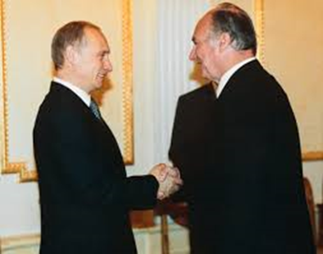
A huge gathering | A very pleasant morning to you all….  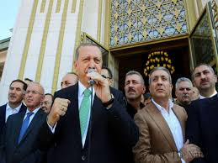

Rajesh has joined the VIT University. On his day of joining, the supervisor asks him to say a few words about himself. The following conversation throws light on some of the common mistakes in spoken English. As the supervisor corrects Rajesh, we too learn the correct expressions.
Good Morning Sir! I am Rajesh. 40 years old. Me married. Have two children. One girl, one boy. Girl five years, boy eight years.
Good Rajesh, but it would be better if you say – I am 40 years old, and I am married. I have two children, a five year old girl and an eight year old boy.
Ok Sir, Thank you
Fine Rajesh, what is your work experience?
I fifteen years service sir. Worked in Vaniyambadi. My home town.
Oh fifteen years! Very good. But again, it will be good if you say, - I have put in fifteen years of service. I was working in my hometown, Vaniyambadi.

